**Ideation Phase**

**Define the Problem Statements**

|  |  |
| --- | --- |
| Date | 3 June 2025 |
| Team ID | LTVIP2025TMID34708 |
| Project Name | Transfer Learning-Based Classification of Poultry Diseases for Enhanced Health Management |
| Maximum Marks | 2 Marks |

**Customer Problem Statement Template:**

Create a problem statement to understand your customer's point of view. The Customer Problem Statement template helps you focus on what matters to create experiences people will love.

A well-articulated customer problem statement allows you and your team to find the ideal solution for the challenges your customers face. Throughout the process, you’ll also be able to empathize with your customers, which helps you better understand how they perceive your product or service.

Reference: <https://miro.com/templates/customer-problem-statement/>

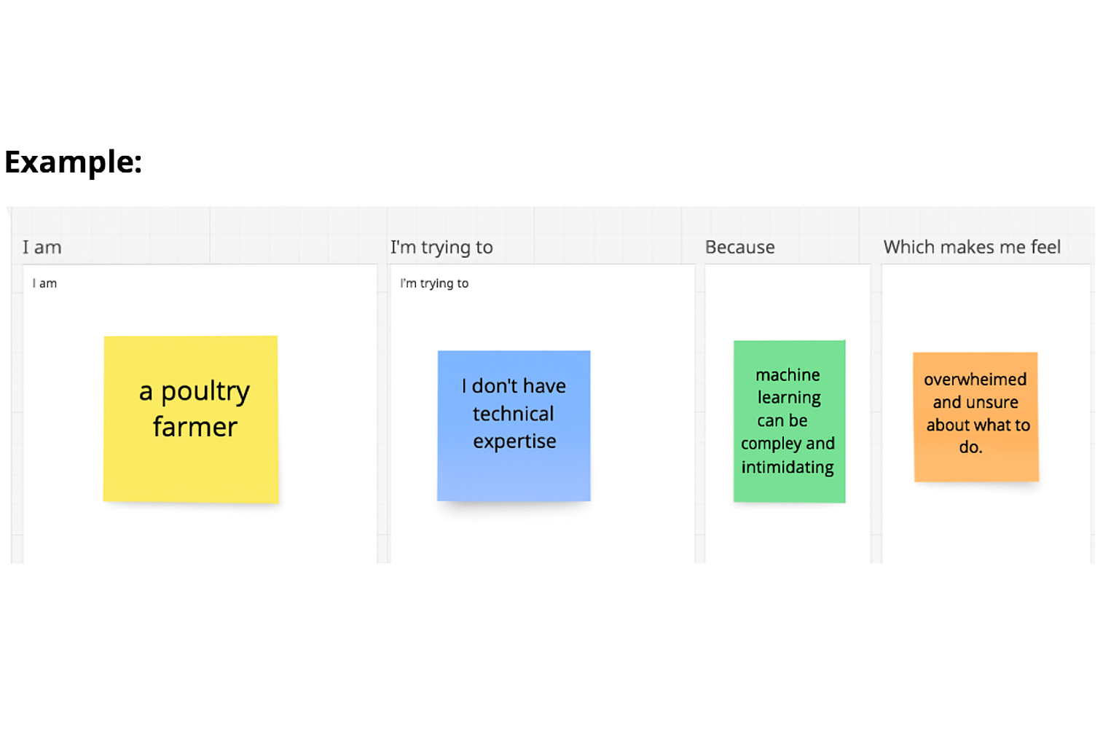

|  |  |  |  |  |  |
| --- | --- | --- | --- | --- | --- |
| **Problem Statement (PS)** | **I am (Customer)** | **I’m trying to** | **But** | **Because** | **Which makes me feel** |
| PS-1 | **I am** a poultry farmer managing a medium-sized farm, | **I’m trying to** identify diseases early to reduce losses and protect my flock | **But** I struggle to recognize symptoms accurately, | **Because** I lack veterinary knowledge and diagnostic tools, | **Which makes me feel** anxious and unsure about my flock’s health. |
| PS-2 | **I am** a local veterinarian supporting small poultry farms, | **I’m trying to** provide quick and accurate disease diagnosis, | **But** I can’t always visit farms immediately, | **Because** travel and manual diagnosis take time, | **Which makes me feel** pressured and worried about delays in treatment. |